Final Internship Project :
PROJECT REPORT

Name : Lekshmy Sajeevan Sindhu
Course : Web Development Course (June batch)

Module 1:
Web Technology Fundamentals

Related Topics:
● Introduction to Web Technologies ● Client-Server Architecture ● Types of Websites

Web workflow
A website design workflow is a structured, step-by-step process that guides a project from the initial idea to launch and ongoing maintenance
When a user interacts with a website, data flows through a three-tier architecture consisting of the Frontend, Backend, and Database.
- Frontend (The Client): The user triggers an action (e.g., clicking "View Profile"). The browser packages this request into an HTTP Request (containing headers, a method like GET or POST, and sometimes a body) and sends it over the internet to the server.
- Backend (The Server): The server receives the request, validates the user's session, executes business logic, and determines what data is needed. It speaks to the database using database-specific drivers or languages (like SQL).
- Database (The Storage): The database processes the query, fetches or updates the requested rows/documents, and sends the raw data back to the backend.
- The Return Trip: The backend formats this data (usually into JSON or HTML) and sends it back to the frontend as an HTTP Response (with a status code like 200 OK). The browser renders the update for the user.
Web pages are returned by the server which are prebuilt source code files built using simple languages such as HTML, CSS, or JavaScript. There is no processing of content on the server (according to the user) in Static Websites. Web pages are returned by the server with no change therefore, static Websites are fast. There is no interaction with databases. Also, they are less costly as the host does not need to support server-side processing with different languages.
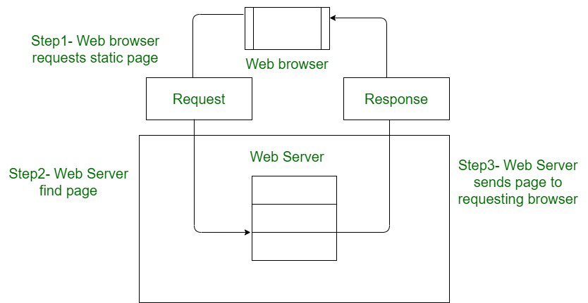

In Dynamic Websites, Web pages are returned by the server which are processed during runtime means they are not prebuilt web pages but they are built during runtime according to the user's demand with the help of server-side scripting languages such as PHP, Node.js, ASP.NET and many more supported by the server. So, they are slower than static websites but updates and interaction with databases are possible.
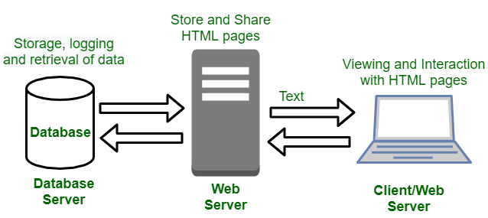

Basic webpage :
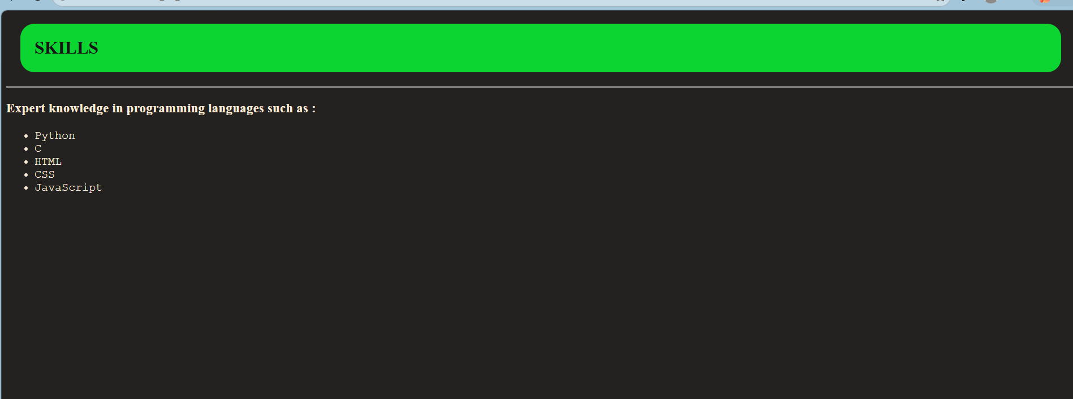

Module 2:
Frontend – HTML

Related Topics:
● HTML Elements, Forms, Lists, Tables Tasks:
● Adding Images, Links, and Special Characters

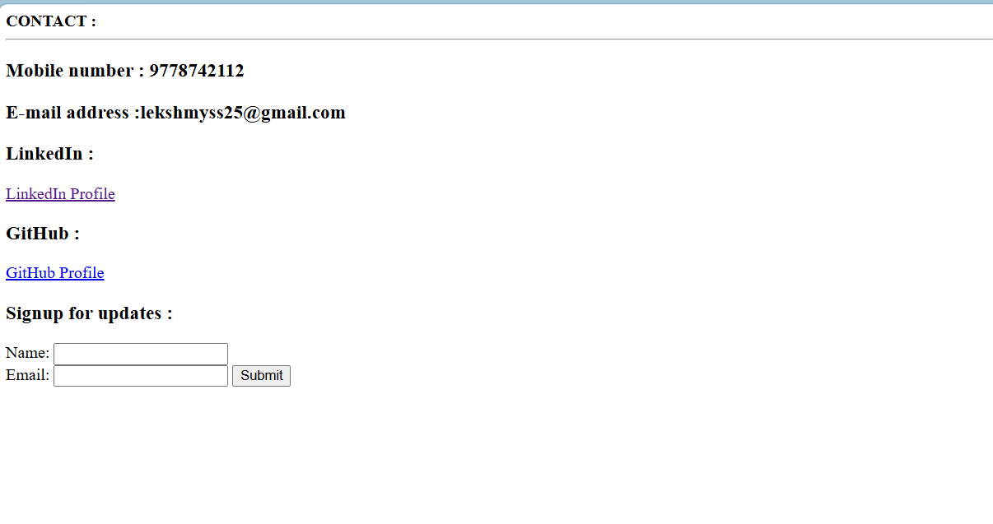
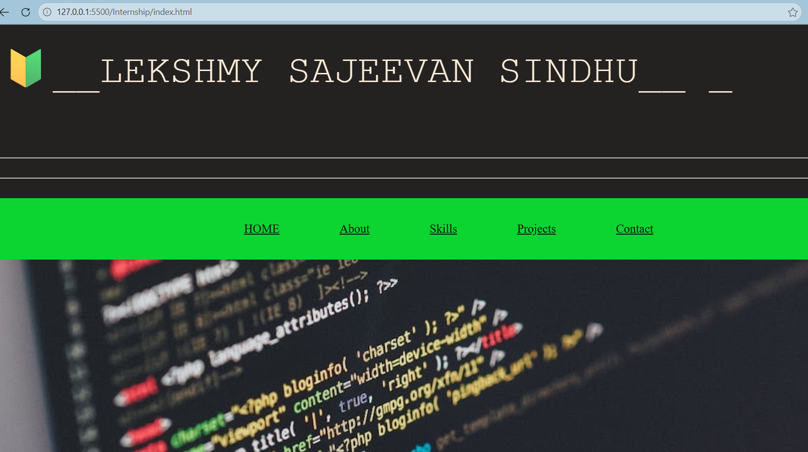

Module 3:
Styling – CSS

Related Topics:
- CSS Selectors, Colors, Fonts, Box Model
- Responsive Layouts

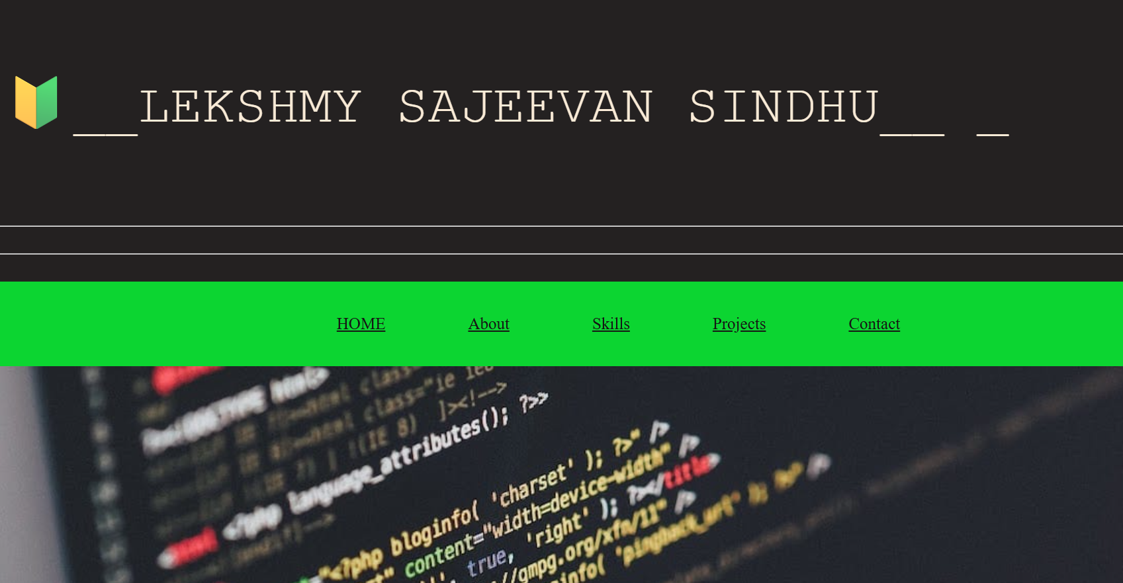

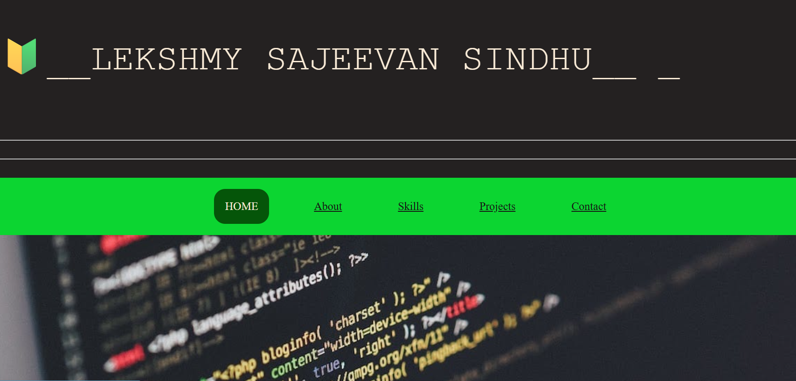

Module 4 :
Dynamic Scripting – JavaScript

Related Topics:
- Variables, Loops, Events, Functions, Cookies
- Page Redirection

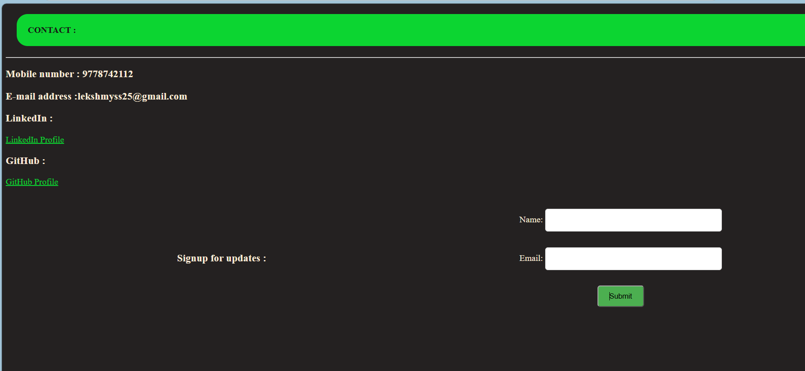
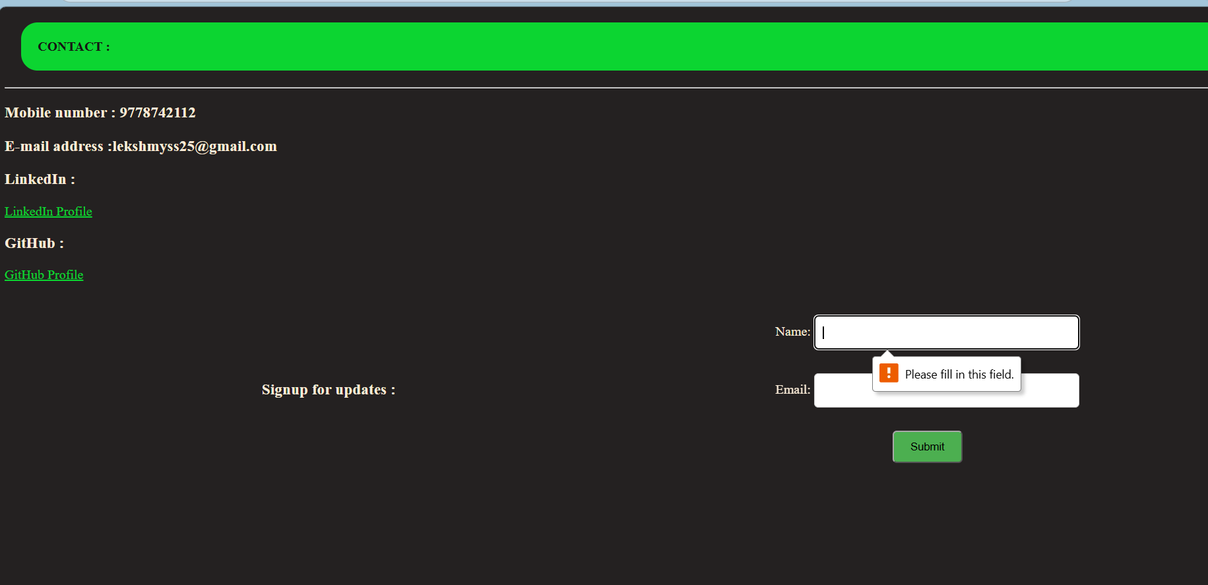

Module 5 :
Advanced JavaScript & DOM

Related Topics:
- DOM Manipulation
- Advanced Form Validation

Module 6 :
Bootstrap Framework

Related Topics:
- Grid System, Typography, Buttons, Modals, Navbars

Module 7 :
React Basics

Related Topics:
- Components, Props, Forms, Project Structure

Module 8 :
React Advanced

Related Topics:

